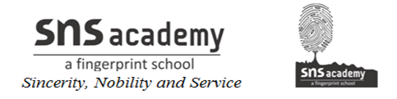
Geometry
Definition of points, lines and shapes in geometry:
Point: A point is the fundamental element of geometry. If we put the tip of a pencil on a paper and press it lightly, we see a very small mark on the paper. This mark is known as a point.
The smallest mark denotes the existence of a point. We say that a point does not have any length, breadth or thickness, but it has a definite position.
It can be named by a capital letter of the English alphabet like A, B, C, ……. etc.
Line: If two points are made at a distance on a surface and are joined by a pencil then a part of a line is formed. The part of the line will be straight if the surface is plane and curved if the surface is curved.
Thus, if we join any two points with a ruler and extend it on both sides, a line is formed.
A line is indicated by drawing arrow-heads on both sides of the part of a line.
The arrow-heads at the ends indicate that the line goes on in both directions. A line has no end, so it has not a definite length.
The name of a line is indicated by two capital letters of the English alphabet.
The symbol ↔ is placed over the letters as AB, CD.

